**ReactJS**

**HandsOn**

**3.CalculateScore.js**

import '../Stylesheets/mystyle.css';

const percentToDecimal = (decimal) => {

  return (decimal.toFixed(2) + '%');

};

const calcScore = (total, goal) => {

  return percentToDecimal(total/goal);

};

export const CalculateScore = ({Name, School, total, goal}) => (

  <div className="formatstyle">

    <h1><font color="Brown">Student Details:</font></h1>

    <div className="Name">

      <b><span>Name: </span></b>

      <span>{Name}</span>

    </div>

    <div className="School">

      <b><span>School: </span></b>

      <span>{School}</span>

    </div>

    <div className="Total">

      <b><span>Total: </span></b>

      <span>{total}</span>

      <span>Marks</span>

    </div>

    <div className="Score">

      <b>Score: </b>

      <span>

        {calcScore(

          total,

          goal

        )}

      </span>

    </div>

  </div>

);

**mystyle.css**

.Name {

  font-weight: 300;

  color: blue;

}

.School {

  color: crimson;

}

.Total {

  color: darkmagenta;

}

.formatstyle {

  text-align: center;

  font-size: large;

}

.Score {

  color: forestgreen;

}

**App.js**

import {CalculateScore} from './Components/CalculateScore';

function App() {

  return (

    <div>

      <CalculateScore Name={"Steeve"}

        School={"DNV Public School"}

        total={284}

        goal={3}

      />

    </div>

  );

}

export default App;

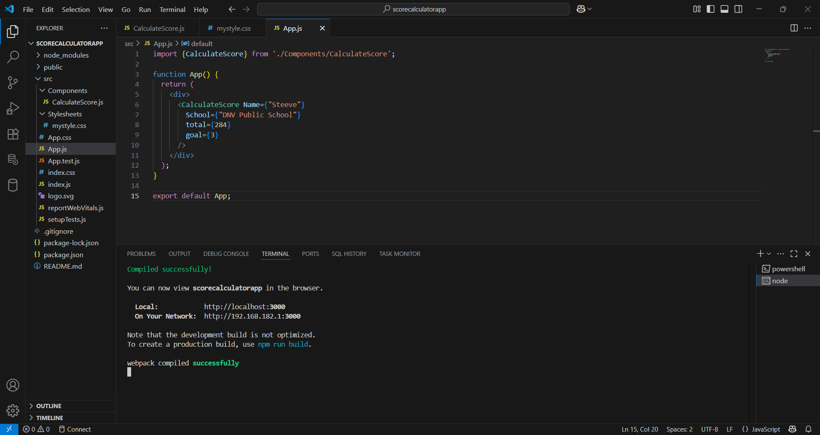

**Output:**

